Day 4 – Digital Footprints
A digital footprint is the collection of information left behind whenever an individual or organization uses the internet. Every website visit, social media post, uploaded image, email, or online account contributes to a digital footprint. Digital footprints are widely used in cybersecurity, digital investigations, brand monitoring, and intelligence analysis.
Digital footprints can reveal valuable information about a person's activities, an organization's operations, or the authenticity of online identities.

1. Personal Digital Footprints
A personal digital footprint refers to all information available online about an individual. Eg: Social media profiles, Blog posts, Comments, Online portfolios, News mentions, Email addresses, Public documents.
Importance: Personal footprints help investigators verify identities, detect fake profiles, understand online behavior, and assess potential security risks.
It can be divided into two main types:

Active Footprints
- Created when you deliberately share information.
- Examples:
  - Social media posts, comments, likes
  - Blog entries or forum contributions
  - Signing up for newsletters or accounts
  - Online shopping and banking activities
- Control: You decide what to share, but once posted, it may remain online permanently.

Passive Footprints
- Generated without your direct input, often in the background.
- Examples:
  - IP addresses logged by websites
  - Cookies tracking browsing habits
  - Device fingerprints and geolocation data
  - Search engine query logs
- Control: Limited, since much of this is collected invisibly.
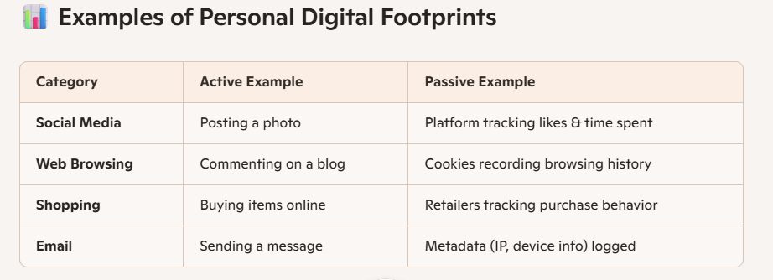

2. Organization Digital Footprints

Definition
An organization footprint includes all publicly accessible information related to a company.

Information Includes
- Official website
- Employee details
- Contact information
- Office locations
- Technologies used
- Job postings
- Press releases
- Social media accounts
- Public repositories
- Domain registration
It includes both intentional presence (like websites and social media) and unintentional traces (like metadata, employee posts, or leaked records).

1. Website & Domain Data
- Domain registration (WHOIS records, DNS, SSL certificates).
- Website architecture, subdomains, and hosting providers.
- Risks: Outdated SSL, exposed admin panels, weak DNS security.

2. Social Media Presence
- Official accounts on LinkedIn, Twitter, Instagram, YouTube.
- Employee activity linking back to the company.
- Risks: Negative reviews, impersonation, brand misuse.

3. Public Records & Filings
- Company registration, press releases, patents, job postings.
- Risks: Competitors or attackers can track growth strategies.

4. Metadata in Documents
- Hidden author names, editing software, timestamps in PDFs, Word files, or images.
- Risks: Reveals internal systems, employee identities, or office locations.

5. Reputation Signals
- Customer reviews, Trustpilot ratings, Glassdoor employee feedback.
- Risks: Negative sentiment impacts investor confidence.
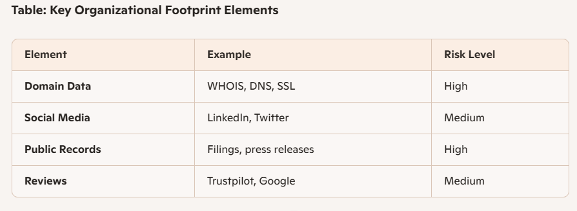
3. Metadata
Metadata literally means “data about data.” Metadata is the hidden or background information attached to digital files, communications, and online activity. It’s often invisible to everyday users but can reveal critical details about when, where, and how something was created or shared.

Examples
For an image:
- Camera model
- Date taken
- GPS location
- Resolution
- File size
For a document:
- Author
- Creation date
- Last modified date
- Software used

1. File Metadata
- Found in documents, images, videos, and audio files.
- Examples:
  - Author name in a Word document
  - Camera model and GPS location in a photo (EXIF data)
  - Editing software used in a PDF

2. Communication Metadata
- Attached to emails, messages, and calls.
- Examples:
  - Email headers (sender IP, time sent, server details)
  - Call logs (time, duration, phone numbers)
  - Chat apps storing timestamps and device info

3. Web Metadata
- Information websites embed for search engines and analytics.
- Examples:
  - Page titles, keywords, descriptions
  - Tracking cookies and analytics tags
  - User session IDs

Importance
Metadata can reveal hidden information that is useful during digital investigations.

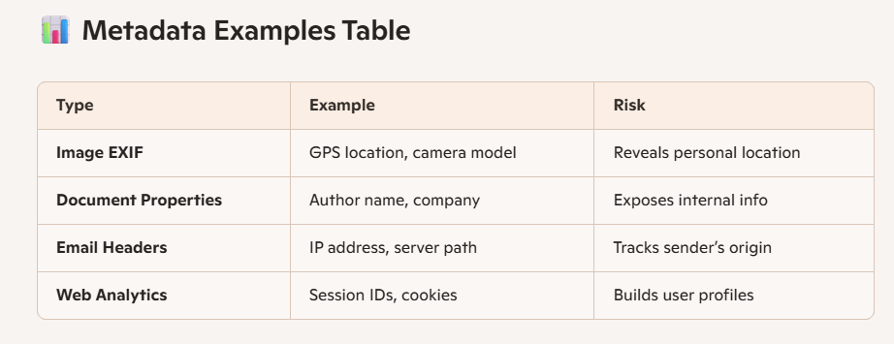

4. Online Identity

Definition
Online identity represents how an individual or organization appears across different online platforms. Online identity is the representation of who you are in the digital world. It’s built from the accounts, usernames, posts, and interactions that connect together to form your virtual persona. Unlike offline identity, it’s often fragmented across platforms but can be pieced together by others — including employers, marketers, or attackers.
Your online identity is the sum of all the information that identifies you on the internet. It includes both intentional choices (like usernames and bios) and unintentional traces (like metadata and linked accounts).

1. Username & Handle Reuse
- Using the same username across platforms makes it easy to connect accounts.
- Example: “Atchaya_123” on Instagram, Twitter, and GitHub → one identity graph.

2. Email & Phone Links
- Many platforms use email or phone numbers as unique identifiers.
- Breach databases often expose these, linking multiple accounts together.

3. Social Media Profiles
- Public posts, photos, and bios shape perception.
- Even private accounts leak identity through friends’ tags or shared content.

4. Metadata & Hidden Signals
- EXIF data in photos, IP addresses in emails, and cookies all tie activity back to you.
- These signals help build a detailed identity profile.
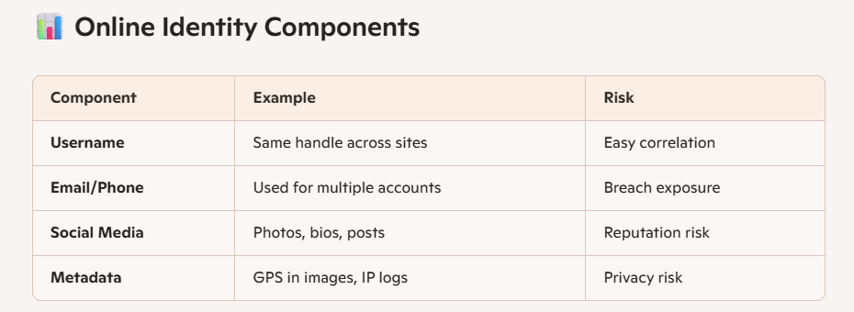

Startup Investigation

Selected Startup: OpenAI

Objective
To investigate the publicly available digital footprint of the startup using OSINT techniques.

Investigation Methodology
The following publicly available sources were examined:
- Official website
- LinkedIn
- GitHub
- X (Twitter)
- News articles
- Search engines

Information Collected



Official Presence
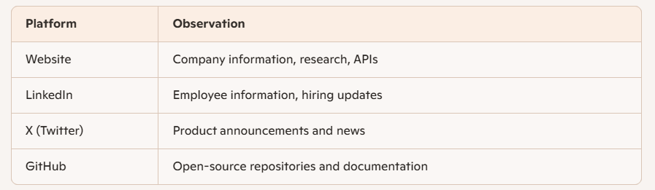

Digital Footprint Analysis
The investigation identified several public digital assets:
- Official website
- Company blog
- Documentation portal
- API documentation
- Career page
- Research publications
- Social media accounts
- Press releases

Metadata Observation
Public documents and images may contain metadata such as:
- Creation date
- File type
- Author
- Software used
Modern organizations often remove sensitive metadata before publishing documents to reduce information leakage.

Online Identity Assessment
The organization maintains a consistent online identity through:
- Verified social media accounts
- Official website
- Professional branding
- Consistent logos
- Verified company information
This consistency helps users distinguish official resources from fake or impersonated accounts.

Findings
The investigation shows that OpenAI maintains a strong and well-managed digital footprint. Publicly available information is distributed across official websites, research publications, documentation, and verified social media platforms. The company follows consistent branding practices and limits unnecessary exposure of sensitive information.

Conclusion
Digital footprints are valuable sources of intelligence for cybersecurity professionals and investigators. By analyzing publicly available information, organizations and individuals can better understand their online exposure, identify security risks, and improve privacy. This practical investigation demonstrates how OSINT techniques can be used to collect publicly available information about an organization without accessing private or confidential data.

Learning Outcome
After completing this task, I learned:
- The difference between personal footprints and organizational footprints.
- How metadata provides additional information about files.
- The importance of maintaining a secure online identity.
- How OSINT techniques can be used to investigate publicly available information about organizations.
- How organizations can reduce digital exposure by managing publicly available information effectively.

